**P210/1**

**HISTORY**

**(National Movements**

**and the New States)**

Paper 1

Jul/Aug 2019

3 Hours

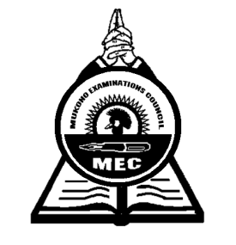

**MUKONO EXAMINATION COUNCIL**

**Uganda Advanced Certificate of Education**

**HISTORY**

**(National Movements and The New States in Africa)**

Paper 1

3 Hours

**INSTRUCTIONS TO CANDIDATES**

*Answer any* ***four*** *questions only*

*Any extra question(s) will not be marked*

*All questions carry equal marks*

*Begin each question on a fresh page.*

*Relevant examples (depth), clear explanations, accuracy of information, good level of communication, presentation of many facts among others are part of impression.*

1. “External factors were primarily responsible for the collapse of the Monarchy in Ethiopia in 1936.” Discuss.
2. Examine the influence of the United Nations Organization (UNO) towards the decolonization of Africa.
3. Account for the delayed decolonization of Algeria up to 1962.
4. To what extent did Ahmed Sokou Toure contribute to the development of Pan Africanism?
5. Assess the role of the Tanganyika African National Union (TANU) in the achievement of independence in Tanganyika.
6. Account for the success of the 1961 – 93 Eritrean war of Liberation.
7. Examine the achievements of the Central African Federation (C.A.F) between 1953 – 1963.
8. To what extent did Fredrick William De Clark contribute to the rise of African majority rule in South Africa in 1994?
9. Account for the continued influence of neo-colonialism in any one post- independence West African state.
10. ‘Lt. Gen. Fredrick Akuffo was largely responsible for his own overthrow in 1979.’ Discuss.

* ***End -***